Appendix
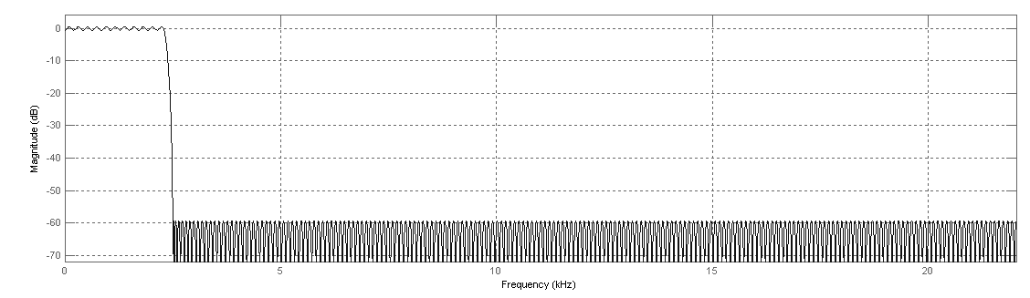Figure 1: Magnitude Response of the 44100 Low Pass Filter
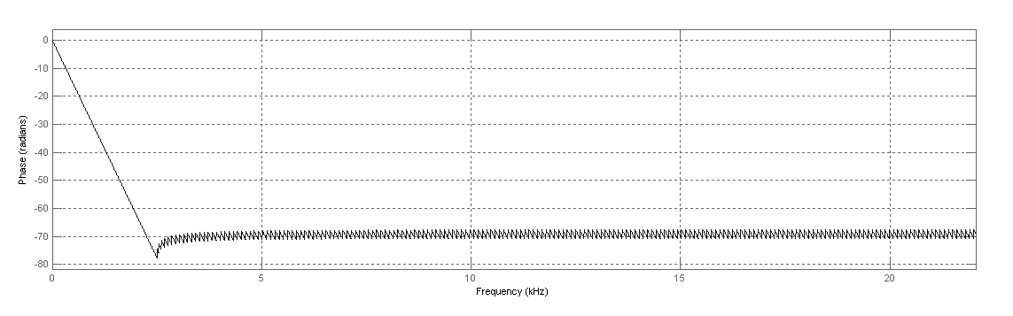Figure 2: Phase Response of the 44100 Low Pass Filter
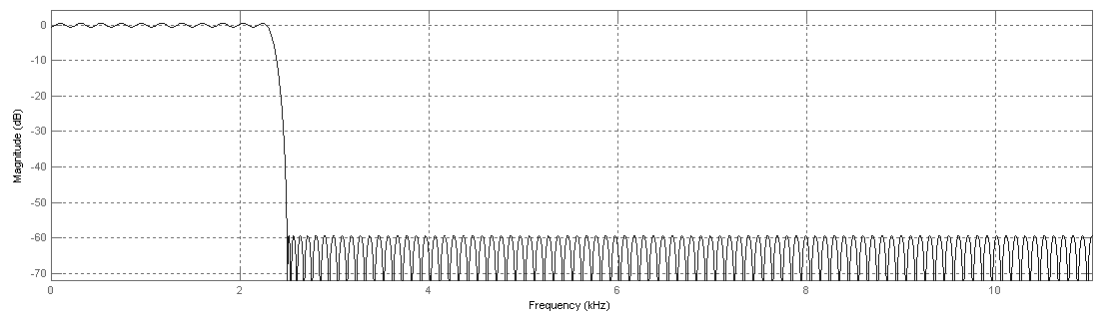Figure 3: Phase Response of the 44100 Low Pass Filter - its similarities to Figure 1 are notable since it is the same basic filter

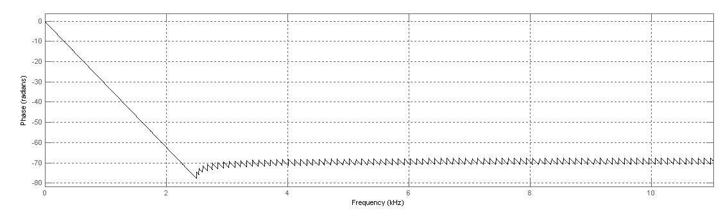Figure 4: Phase Response of the 44100 Low Pass Filter - its similarities to Figure 2 are notable since it is the same basic filter
int bLowPassCoarseLength = 437;
double bLowPassCoarse[437] = {
0.0005801473440578, 5.8031829618e-005,-1.68873639982e-005,-0.0001527308696682,
-0.0003531319021155,-0.0006174752976462,-0.0009402416419882,-0.001310046455414,
-0.001710063440517,-0.002118240870112,-0.002508936094207,-0.002854273333745,
-0.003126694966973,-0.003300947399438,-0.003356914158732,-0.003281415620313,
-0.003070346104153,-0.002729348993704,-0.002274425328617,-0.001730817402552,
-0.001131870259154,-0.0005161490726658,7.504179453673e-005,0.0006015727283088,
0.001027495082417, 0.001324822228089, 0.001475749643523, 0.001474947541438,
0.001329662736264, 0.001059756756212,0.0006954571574575,0.0002754127604765,
-0.0001574032023329,-0.0005590531973511,-0.0008899173157137,-0.001117734577491,
-0.001221431313671,-0.001191287939578,-0.001032531501804,-0.0007646281530493,
-0.0004155920727209,-2.473832501918e-005,0.0003661270815194,0.0007142824811753,
0.0009820389852375, 0.001139989088883, 0.001170715606975, 0.00107040646382,
0.0008496543020175,0.0005322462798029,0.0001528609686369,-0.0002467142541175,
-0.0006220251142781,-0.0009308400506181,-0.001137795407826,-0.001218416141244,
-0.001161967456369, -0.00097288769869,-0.0006705746087826,-0.0002873813970787,
0.0001346687432342,0.0005485841099868,0.0009073863837083, 0.001169503620594,
0.001303396355468, 0.00129147785418, 0.001132241018962,0.0008409208055287,
0.0004478359553185,-4.496216045334e-006,-0.0004660361503263,-0.0008843938052375,
-0.001211149322965,-0.001407151305886,-0.001447340576714,-0.001323248733582,
-0.001045555698408,-0.0006422519334134,-0.0001560688828728,0.0003593433016902,
0.0008462503846455, 0.001248387438047, 0.001518003563248, 0.001621099560957,
0.001541879107719, 0.001284836640422, 0.000874843665348,0.0003547569092837,
-0.0002189457449883,-0.0007822516629929,-0.001270701088003,-0.001626693980861,
-0.001806256495171,-0.001784372127608,-0.001558302304251,-0.001148490311154,
-0.0005968268382021,3.754186960359e-005,0.0006844345674674, 0.001270450114719,
0.0017271184145, 0.001998950107887, 0.002049962811849, 0.001868396103313,
0.001468643179971,0.0008904508915512,0.0001948997757437,-0.0005418511771341,
-0.001236892220354,-0.001809650943849,-0.002191404556738,-0.002333274516879,
-0.002212391175892,-0.001835016323322,-0.001237223343398,-0.0004808582867018,
0.0003521626253042, 0.001168870981321, 0.001875587590266, 0.002388386267006,
0.002643134280855, 0.00260321244569, 0.002264579832456, 0.00165715545156,
0.0008424096268757,-9.270232506523e-005,-0.001044931746322,-0.001905976515532,
-0.002574726309041, -0.00296891583703,-0.003035167135844,-0.002755864838759,
-0.002152329382642,-0.001283545893148,-0.0002405939625761,0.0008627075706931,
0.00190205327551, 0.00275653537714, 0.003322443067891, 0.003525760415148,
0.003331416071976, 0.002748625561185, 0.001831239080329,0.0006731751344559,
-0.0006011093329557,-0.001849679013502,-0.002928743446397,-0.003708867027356,
-0.004090385628875,-0.004015647515377,-0.003477063867078,-0.002519707762508,
-0.001238259579042,0.0002324342403674, 0.001730742200149, 0.003086078039954,
0.004137714530548, 0.004753571303073, 0.004846274168015, 0.004384809493616,
0.003400200521115, 0.001984446267866,0.0002824177587278,-0.001522410139733,
-0.003227312547312,-0.004632456829864,-0.005563805150608, -0.00589383028042,
-0.00555811864012,-0.004565255786525,-0.002999241853496,-0.001013225568325,
0.001184614389935, 0.003352083829756, 0.005238766514005, 0.006613921010448,
0.007293459810757, 0.007163156899191, 0.006194914330708, 0.004454468405084,
0.002098895831429,-0.0006360325184182,-0.003458123500893,-0.006048227475891,
-0.008094455196282,-0.009327378509172,-0.009552763768267,-0.008677674581933,
-0.006727241507668,-0.003849576256744,-0.000307656464822, 0.003541917176334,
0.00728109107941, 0.01047186439248, 0.01270202805729, 0.01363190043795,
0.01303632960461, 0.01083814749409, 0.007128711472189, 0.002173164678698,
-0.003601337025557,-0.009633811490473, -0.01527259612164, -0.01982965313647,
-0.02264185083599, -0.02313331984881, -0.02087364385072, -0.01562567191085,
-0.007378940677049, 0.003635819212505, 0.0169521500314, 0.03189424208277,
0.04762201492833, 0.06319161453069, 0.07762641977966, 0.0899926277066,
0.09947264020903, 0.105430369778, 0.1074623406961, 0.105430369778,
0.09947264020903, 0.0899926277066, 0.07762641977966, 0.06319161453069,
0.04762201492833, 0.03189424208277, 0.0169521500314, 0.003635819212505,
-0.007378940677049, -0.01562567191085, -0.02087364385072, -0.02313331984881,
-0.02264185083599, -0.01982965313647, -0.01527259612164,-0.009633811490473,
-0.003601337025557, 0.002173164678698, 0.007128711472189, 0.01083814749409,
0.01303632960461, 0.01363190043795, 0.01270202805729, 0.01047186439248,
0.00728109107941, 0.003541917176334,-0.000307656464822,-0.003849576256744,
-0.006727241507668,-0.008677674581933,-0.009552763768267,-0.009327378509172,
-0.008094455196282,-0.006048227475891,-0.003458123500893,-0.0006360325184182,
0.002098895831429, 0.004454468405084, 0.006194914330708, 0.007163156899191,
0.007293459810757, 0.006613921010448, 0.005238766514005, 0.003352083829756,
0.001184614389935,-0.001013225568325,-0.002999241853496,-0.004565255786525,
-0.00555811864012, -0.00589383028042,-0.005563805150608,-0.004632456829864,
-0.003227312547312,-0.001522410139733,0.0002824177587278, 0.001984446267866,
0.003400200521115, 0.004384809493616, 0.004846274168015, 0.004753571303073,
0.004137714530548, 0.003086078039954, 0.001730742200149,0.0002324342403674,
-0.001238259579042,-0.002519707762508,-0.003477063867078,-0.004015647515377,
-0.004090385628875,-0.003708867027356,-0.002928743446397,-0.001849679013502,
-0.0006011093329557,0.0006731751344559, 0.001831239080329, 0.002748625561185,
0.003331416071976, 0.003525760415148, 0.003322443067891, 0.00275653537714,
0.00190205327551,0.0008627075706931,-0.0002405939625761,-0.001283545893148,
-0.002152329382642,-0.002755864838759,-0.003035167135844, -0.00296891583703,
-0.002574726309041,-0.001905976515532,-0.001044931746322,-9.270232506523e-005,
0.0008424096268757, 0.00165715545156, 0.002264579832456, 0.00260321244569,
0.002643134280855, 0.002388386267006, 0.001875587590266, 0.001168870981321,
0.0003521626253042,-0.0004808582867018,-0.001237223343398,-0.001835016323322,
-0.002212391175892,-0.002333274516879,-0.002191404556738,-0.001809650943849,
-0.001236892220354,-0.0005418511771341,0.0001948997757437,0.0008904508915512,
0.001468643179971, 0.001868396103313, 0.002049962811849, 0.001998950107887,
0.0017271184145, 0.001270450114719,0.0006844345674674,3.754186960359e-005,
-0.0005968268382021,-0.001148490311154,-0.001558302304251,-0.001784372127608,
-0.001806256495171,-0.001626693980861,-0.001270701088003,-0.0007822516629929,
-0.0002189457449883,0.0003547569092837, 0.000874843665348, 0.001284836640422,
0.001541879107719, 0.001621099560957, 0.001518003563248, 0.001248387438047,
0.0008462503846455,0.0003593433016902,-0.0001560688828728,-0.0006422519334134,
-0.001045555698408,-0.001323248733582,-0.001447340576714,-0.001407151305886,
-0.001211149322965,-0.0008843938052375,-0.0004660361503263,-4.496216045334e-006,
0.0004478359553185,0.0008409208055287, 0.001132241018962, 0.00129147785418,
0.001303396355468, 0.001169503620594,0.0009073863837083,0.0005485841099868,
0.0001346687432342,-0.0002873813970787,-0.0006705746087826, -0.00097288769869,
-0.001161967456369,-0.001218416141244,-0.001137795407826,-0.0009308400506181,
-0.0006220251142781,-0.0002467142541175,0.0001528609686369,0.0005322462798029,
0.0008496543020175, 0.00107040646382, 0.001170715606975, 0.001139989088883,
0.0009820389852375,0.0007142824811753,0.0003661270815194,-2.473832501918e-005,
-0.0004155920727209,-0.0007646281530493,-0.001032531501804,-0.001191287939578,
-0.001221431313671,-0.001117734577491,-0.0008899173157137,-0.0005590531973511,
-0.0001574032023329,0.0002754127604765,0.0006954571574575, 0.001059756756212,
0.001329662736264, 0.001474947541438, 0.001475749643523, 0.001324822228089,
0.001027495082417,0.0006015727283088,7.504179453673e-005,-0.0005161490726658,
-0.001131870259154,-0.001730817402552,-0.002274425328617,-0.002729348993704,
-0.003070346104153,-0.003281415620313,-0.003356914158732,-0.003300947399438,
-0.003126694966973,-0.002854273333745,-0.002508936094207,-0.002118240870112,
-0.001710063440517,-0.001310046455414,-0.0009402416419882,-0.0006174752976462,
-0.0003531319021155,-0.0001527308696682,-1.68873639982e-005, 5.8031829618e-005,
0.0005801473440578
};
Listing 1: Coefficients for Low Pass Filter 44100 Hertz

int bLowPassCoarseLength22k = 219;
double bLowPassCoarse22k[219] = {
0.0006315535619057,-2.060388792281e-005,-0.0006923662620402,-0.001866061006859,
-0.00340688018731,-0.005007871132203,-0.006248203834422,-0.006714267833816,
-0.006146907976149,-0.004559653541978,-0.002276845612575,0.0001369606552593,
0.00204381003141, 0.002944174794398, 0.002656100518694, 0.001391058372311,
-0.000311912353415,-0.001776520467832,-0.002439361576471,-0.002063599511922,
-0.0008309358070758, 0.000731264103919, 0.0019624572143, 0.002340042946158,
0.001698424658122,0.0003053724118694,-0.001244008430384,-0.002275175572833,
-0.002323704090659, -0.00134123217655,0.0002692534936317, 0.00181467817851,
0.002606493647898, 0.002265120032755, 0.000896161629922,-0.0009312572410418,
-0.002421925188645,-0.002894694776807,-0.002091657814829,-0.0003129613677984,
0.001691838034708, 0.003035538363763, 0.003083705504742, 0.001749849070589,
-0.0004376360410784, -0.0025413092633, -0.00361279817581,-0.003117462740898,
-0.00119489990434, 0.001367398528347, 0.003452962707955, 0.004098853131138,
0.002936449036699,0.0003888995559697,-0.002475024606508,-0.004385004869046,
-0.004427927069249,-0.002478671474123,0.0006993093366131, 0.003745987658561,
0.00528166572317, 0.004525515886824, 0.001682402330872,-0.002091164894911,
-0.005149957980915,-0.006070459260398,-0.004304635868527,-0.0004813699110309,
0.003803892331703, 0.006644766261426, 0.006663043836924, 0.003663465201138,
-0.00120036857041,-0.005854579199934,-0.008177097896694,-0.006949895263074,
-0.002472257370129, 0.003465286479372, 0.008278281607747, 0.00969432512445,
0.006801089479634, 0.000564720680804,-0.006455191536777, -0.01112806227543,
-0.01111611237999,-0.005997435720254, 0.002371396850734, 0.01048064221594,
0.0145904244026, 0.01239290553315, 0.004199581087902,-0.006916442867813,
-0.01619132408943, -0.01910996796684, -0.01346017299927,-0.0006211394404633,
0.01455738440354, 0.025401260097, 0.02607249338748, 0.01425998389852,
-0.00719788770892, -0.03053901123517, -0.04527723688361, -0.04174162131835,
-0.01475387795663, 0.03390607976434, 0.09524364467265, 0.1552506101532,
0.1989418460493, 0.2149208280712, 0.1989418460493, 0.1552506101532,
0.09524364467265, 0.03390607976434, -0.01475387795663, -0.04174162131835,
-0.04527723688361, -0.03053901123517, -0.00719788770892, 0.01425998389852,
0.02607249338748, 0.025401260097, 0.01455738440354,-0.0006211394404633,
-0.01346017299927, -0.01910996796684, -0.01619132408943,-0.006916442867813,
0.004199581087902, 0.01239290553315, 0.0145904244026, 0.01048064221594,
0.002371396850734,-0.005997435720254, -0.01111611237999, -0.01112806227543,
-0.006455191536777, 0.000564720680804, 0.006801089479634, 0.00969432512445,
0.008278281607747, 0.003465286479372,-0.002472257370129,-0.006949895263074,
-0.008177097896694,-0.005854579199934, -0.00120036857041, 0.003663465201138,
0.006663043836924, 0.006644766261426, 0.003803892331703,-0.0004813699110309,
-0.004304635868527,-0.006070459260398,-0.005149957980915,-0.002091164894911,
0.001682402330872, 0.004525515886824, 0.00528166572317, 0.003745987658561,
0.0006993093366131,-0.002478671474123,-0.004427927069249,-0.004385004869046,
-0.002475024606508,0.0003888995559697, 0.002936449036699, 0.004098853131138,
0.003452962707955, 0.001367398528347, -0.00119489990434,-0.003117462740898,
-0.00361279817581, -0.0025413092633,-0.0004376360410784, 0.001749849070589,
0.003083705504742, 0.003035538363763, 0.001691838034708,-0.0003129613677984,
-0.002091657814829,-0.002894694776807,-0.002421925188645,-0.0009312572410418,
0.000896161629922, 0.002265120032755, 0.002606493647898, 0.00181467817851,
0.0002692534936317, -0.00134123217655,-0.002323704090659,-0.002275175572833,
-0.001244008430384,0.0003053724118694, 0.001698424658122, 0.002340042946158,
0.0019624572143, 0.000731264103919,-0.0008309358070758,-0.002063599511922,
-0.002439361576471,-0.001776520467832,-0.000311912353415, 0.001391058372311,
0.002656100518694, 0.002944174794398, 0.00204381003141,0.0001369606552593,
-0.002276845612575,-0.004559653541978,-0.006146907976149,-0.006714267833816,
-0.006248203834422,-0.005007871132203, -0.00340688018731,-0.001866061006859,
-0.0006923662620402,-2.060388792281e-005,0.0006315535619057
};
Listing 2: Coefficients for Low Pass Filter 22050 Hertz
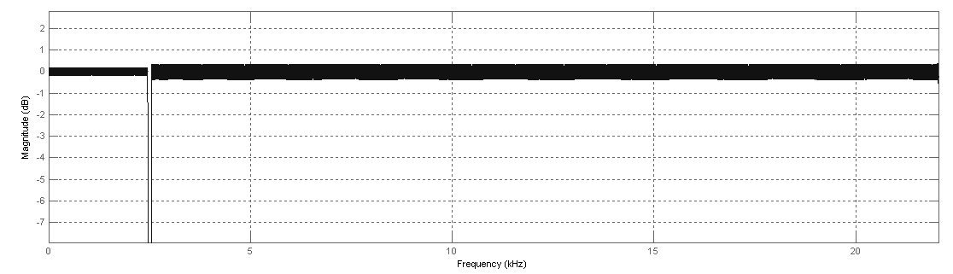Figure 5: Band Stop Magnitude Response
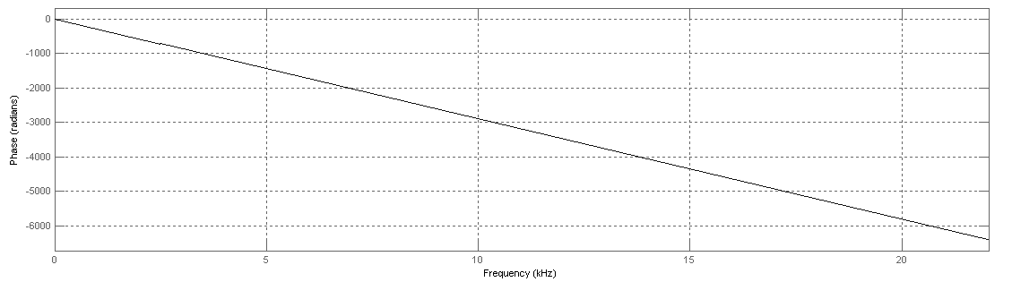Figure 6: Band Stop Phase Response

